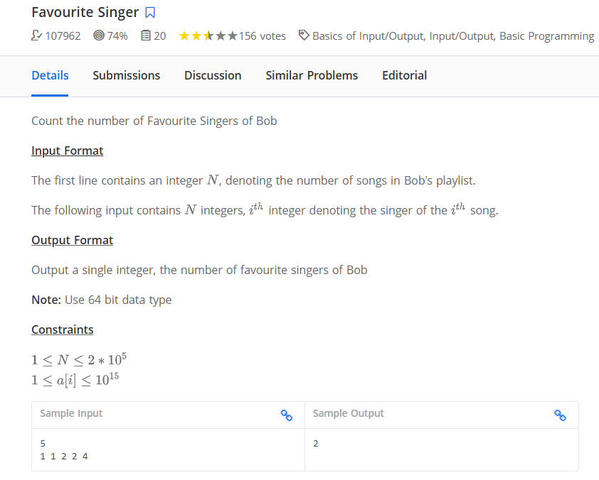
no_of_songs = int(input())

singer = list(map(int,input().split()))

# print(no_of_songs)
# print(singer)

# initialize empty dict, if singer present in dict its value added by one else assign value 1 for 1st time
d = {}

for j in singer:
if j in d:
d[j] +=1
else:
d[j] = 1

# Find the maximum frequency
max_freq = max(d.values())
#print(max_freq)

# find no of singers having max freq
max_singer_cnt = 0
for count in d.values():
if count == max_freq:
max_singer_cnt += 1
print(max_singer_cnt)

# using counter
from collections import Counter
no_of_songs = int(input())
singer = list(map(int,input().split()))
freq = Counter(singer)
#print(freq)
max_freq = max(freq.values())
#print(max_freq)
max_freq_cnt = 0
for count in freq.values():
if count == max_freq:
max_freq_cnt += 1
print(max_freq_cnt)
====================== end

